Purdue Webclock
Guide
Recording and Editing Time
Last Updated 3/20/2019

Contents
Policies & Concepts 3
Employee Responsibilities 3
Supervisor Responsibilities 3
Resources 3
Support 3
Technical Requirements 3
Notifications 4
Rounding 4
Overtime 4
Holidays, Moving Holidays, Holiday Emergency Work 5
Supervisor Approval Process 5
WebClock Functionality 6
Accessing Purdue Webclock 6
Record Time; Address Missed Punches 7
View History, Add or Edit Time Pairs 9
View History 9
Edit Time Pairs 10
Add Time Pairs 12

Policies & Concepts

Employee Responsibilities
In Purdue Webclock Employees are responsible for:
- Accurately recording time worked using the appropriate access point
- Selecting the appropriate job when recording time (if employee records time for multiple jobs using the webclock)
- Proactively working with their supervisor to resolve issues as needed (i.e. missing time, missed punches, etc.)
- Ensuring that their time is recorded completely and accurately for each pay period by the deadline required by their supervisor
- Remember: The time entered into the system will be considered true and accurate as of the end of an employee’s pay period. It is the employee’s responsibility to review their time often (at least at the end of each shift and at the end of the pay period) to make sure the recorded hours are true and correct; and to review and confirm the accuracy of any changes that a supervisor makes to time entries.

Supervisor Responsibilities
In Purdue Webclock, Supervisors are responsible for:
- Proactively working with their employees to resolve issues as needed (i.e. missing time, missed punches, etc.)
- Reviewing/approving all time pairs for all of their employees by 12:00pm on the Tuesday following the end of each pay period
- Proactively working with their business office to update employee work schedules and report costing exceptions for their employees’ time worked
- The Purdue Webclock inherits SAP Org Structure. Supervisors are only responsible for and able to access/edit time pairs of employees of whom which they are the supervisor of record in SAP.
- Remember: The time entered into the system will be considered true and accurate as of the end of an employee’s pay period. It is the employee’s responsibility to review their time often (at least at the end of each shift and at the end of the pay period) to make sure the recorded hours are true and correct; and to review and confirm the accuracy of any changes that a supervisor makes to time entries.

Resources
The most current versions of all timekeeping resources for Employees and Supervisors can be found on the Payroll’s SuccessFactors Timekeeping website. https://www.purdue.edu/timehelp

Support
Please contact your supervisor with any Webclock-related questions or concerns.

Technical Requirements
Supported browsers: Chrome, Safari, Edge, Firefox, Internet Explorer
Mobile access: Device must have a web browser and a WIFI or data connection

Notifications
The WebClock provides a Notification Center for Employees (one Notification Center per position held).
Employees receive notifications when a time record is changed (edited/added), time pairs are approved, time pairs are rejected, and when punches are missed.
Supervisors do not receive notifications.

Rounding
- The Webclock assesses the total time duration of the time pair to determine how to round.
  - First, Webclock determines the total time duration for the time pair. Examples: 4 hours 7 minutes, 8 hours 5 minutes, etc.
  - If the total time duration does not correspond to a number of minutes representing a tenth of an hour (see Minutes to Tenths table below), Webclock will round the IN punch down (in the employee’s favor) so that the total time duration matches a tenth of an hour.
Minutes Translated to Tenths  0:06 = .1  0:12 = .2  0:18 = .3  0:24 = .4  0:30 = .5  0:36 = .6  0:42 = .7  0:48 = .8  0:54 = .9  1:00 = 1.0 | Punch Type Punch Time Duration Rounded Punch Time Final Duration  IN 7:15 AM 4 hours, 47 minutes 7:14 AM 4 hours, 48 minutes  OUT 12:02 PM N/A  IN 1:54 PM 2 hours, 50 minutes 1:50 PM 2 hours, 54 minutes  OUT 4:44 PM N/A  IN 6:03 PM 3 hours, 6 minutes N/A 3 hours, 6 minutes  OUT 9:09 PM N/A

Overtime
The Purdue Webclock adheres to the University policy regarding overtime. When a full time employee works over 40 hours in a workweek, the time is will be designated as overtime when it transfers to SuccessFactors for payroll. “Hours worked” in a work week will consist only of hours actually worked. (Exception: Worker’s Compensation, University Holidays).

Overtime for employees with multiple positions will be calculated when the time recorded using the webclock is moved to SuccessFactors prior to Payroll running. Overtime will be charged to each position based on the ratio of hours worked across the employee’s positions for that week.

Overtime is viewable by the supervisor and employees on the Timesheet accessible via SuccessFactors. (Found on the employee’s record in the My Info section – click the Timesheet tile)

Holidays, Moving Holidays, Holiday Emergency Work
Holidays
Holiday premiums are auto-calculated when time recorded using the webclock is moved to SuccessFactors to be paid.

Moving Holidays
Moving Holidays takes place within SuccessFactors Time Off tile (not within the Webclock). Individuals whose work schedule does not include a given University Holiday can use the time off feature within SuccessFactors to request Holiday on any day during the week (Monday through Sunday; Sunday through Saturday (dispatchers only)) of the holiday. Exception: Police and Fire may request Holiday leave at any time throughout the year.

Unplanned Work During an Emergency
When essential personnel work during an emergency, the hours are paid at time and a half. The employee or their supervisor must enter the time on the employee’s timesheet in Employee Central Time (ECT) using time type Campus Service Disruption. For details on how to enter time in ECT, see www.purdue.edu/timehelp (QRG: Time Entry – Positive Duration)

Unplanned Work on a Holiday
When employees are unexpectedly required to work on a holiday, Call Back should be indicated and the employee should record time as usual. The holiday premium will be automatically applied.

Supervisor Approval Process
All time recorded for the previous pay period by the employee before 12:00pm on the Tuesday following the end of the pay period will be paid, as long as the supervisor has not declined the time. Lack of supervisor approval will not prevent the time from being paid, but supervisors should review and take action on the time at their earliest convenience.

Time recorded for the previous pay period by the employee after the 12:00pm Tuesday deadline must be approved by the supervisor in order for it to be paid. The supervisor must approve prior to when payroll locks to begin the payment process. Payroll lock occurs at variable times between 12:00pm and 5:00pm on Tuesday.

If an employee submits changes to their recorded time after approval by the supervisor, the supervisor must review and approve the revised time in order for it to be paid. Changes to previously approved time/timesheets will never be paid unless approved by the supervisor.

WebClock Functionality
 |  | Accessing Purdue Webclock
The Purdue webclock can be accessed via four different access points. Your department will designate a best practice as far as which access method you should utilize.
OneCampus Portal  Employee Launchpad  SuccessFactors | OneCampus Portal  Timekeeping System  Webclock |  | Web Browser | Kiosk
Navigate to the One Campus Employee Portal (one.purdue.edu)  Click the Employee Launchpad tile.  Log in using your BoilerKey.  On the homepage, click the WebClock tile. | Navigate to the One Campus Employee Portal (one.purdue.edu)  Click the Timekeeping System tile.  Log in using your BoilerKey. |  | On your computer or mobile device’s web browser, navigate to webclock.purdue.edu  This link can be bookmarked or saved as a favorite for convenience.  Log in using Purdue User ID and BoilerKey passphrase. | Kiosk are iPads designated for Webclock use, equipped with a card reader and typically mounted to a wall.  At a kiosk, swipe your Purdue ID Card through the card reader.

Record Time; Address Missed Punches
Access the Purdue Webclock
Access the webclock via the Desktop, Mobile Device, or Kiosk access point, as appropriate.
Note: If using a mobile device, enable location services (steps vary by device – typically in Privacy settings).
Clock In or Clock Out
If you hold multiple positions, tap or click the position toward which you wish to record time. | 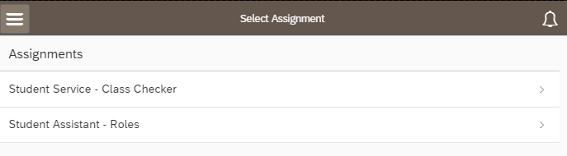
If you supervise others who utilize the webclock to enter time,  - Click to open the menu in the upper left corner of the screen.  - Under Employee View, click My Time. | 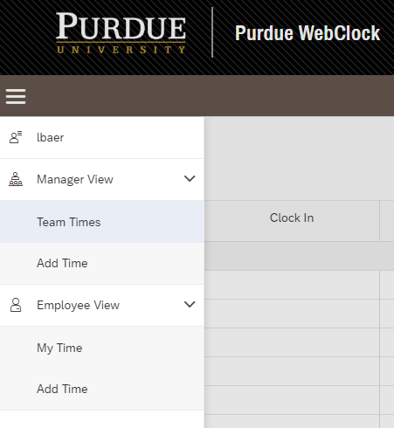  2  1
For 2 hour Call Back premium: If the time to be recorded is eligible for Call Back pay, tap the slider so that YES is displayed.  Click or Tap Clock In (or Clock Out)  - After Clock In has been clicked or tapped, the button will change to read Clock Out. | 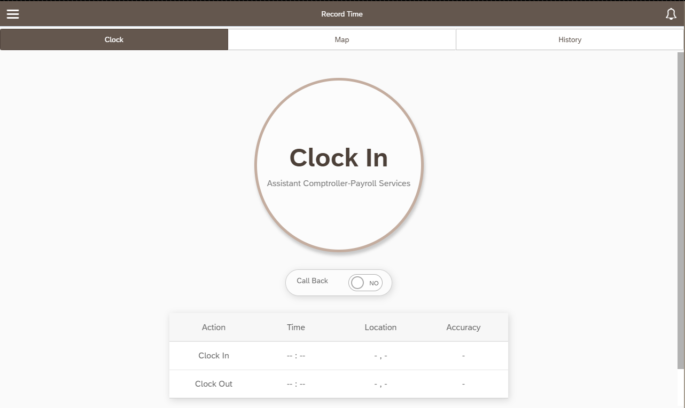  2  1  (if applicable)
Clocking Out  - After Clock Out, click or tap OK to acknowledge that you wish to clock out.  Note: On the Kiosk, users are automatically logged out after Clock In or Clock Out is tapped. | 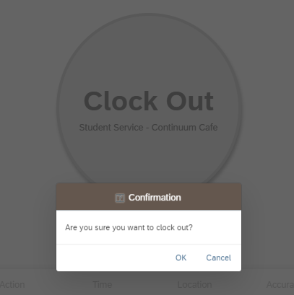
Missed Clock In / Clock Out
If a punch is missed and is not corrected prior to the payroll deadline, time for that day will not be paid. Time for all other days in the pay period will be paid.
- For current shift
If Clock In was missed
    - Clock In and then immediately Clock Out.
    - Use Edit Time Pair steps to manually change the Clock In time.
    - If a user Clocks In and does not Clock Out within 12 hours, a notification will display the next time the user accesses the system suggesting that a punch may have been missed.
If Clock Out was missed
    - Clock Out (to end the too-long time pair), Clock In (if applicable, to begin new shift).
    - Use Edit Time Pair steps to edit the Clock Out time of the too-long time pair.
- For previous shift
If Clock In and Clock Out were missed
  - Use Add Time Pair steps to add the Clock In and Clock Out date and time.
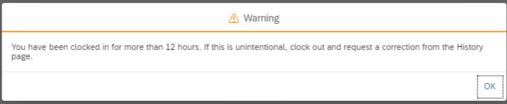

View History, Add or Edit Time Pairs
History contains the time pairs recorded per position for the current pay period and one pay period previous. It can be thought of as the timesheet.
Please select low-volume usage times if completing any of these tasks on a kiosk or other shared device.
Access the Purdue Webclock
Access the webclock via the Desktop, Mobile Device, or Kiosk access point, as appropriate.

View History
If you hold multiple positions, choose the position for which you wish to view History.
Click or tap History in the menu bar. | 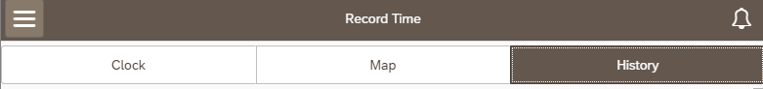
Time pairs for the current and previous pay periods are displayed.  Status column indicates whether or not supervisor has reviewed the time pair. (Possible statuses are PENDING, APPROVED, DECLINED)  Note: For employees with multiple positions, if time is recorded toward the wrong position, the employee must request that the supervisor of the position for which time was incorrectly recorded decline the time pair. The employee must use then Add Time feature to add a time pair to the other position. See Add Time Pairs for additional details. | 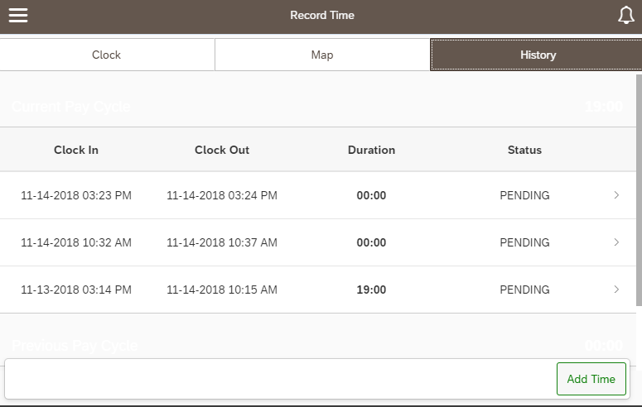

Edit Time Pairs
Employees can edit time pairs at any time within the current and two previous pay periods.

Please select low-volume usage times if completing any of these tasks on a kiosk or other shared device.

Time Pairs are edited due to incorrect punches (early or late, in or out).

Newly edited pairs will in the supervisor’s queue as PENDING.

If completing this task after you suspect your supervisor has completed their final review prior to the Payroll deadline, please notify them that you have made a change so that they are prompted to review the change.
Click or tap History in the menu bar.

Tap or click the line that lists the pair you wish to edit

Use the Reason drop-down menu to choose the reason for the edit |  | 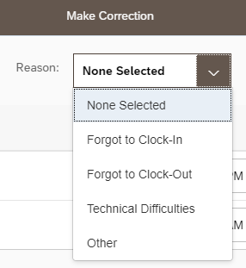
Tap or click the calendar icon on the appropriate line to edit the Clock In or Clock Out time. |  | 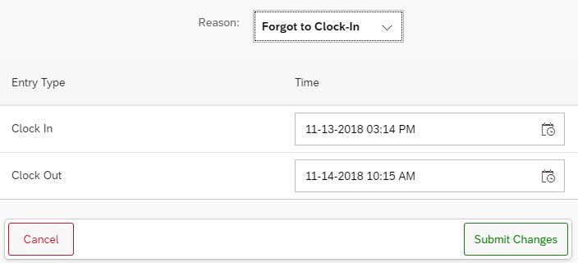
Use the calendar and time slider to indicate the adjusted date and time.  Click or tap OK |  | 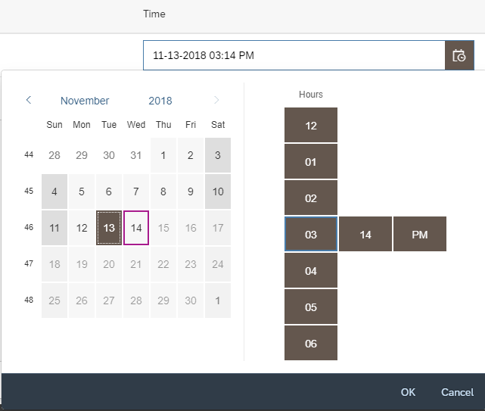
Click Submit Changes |  | 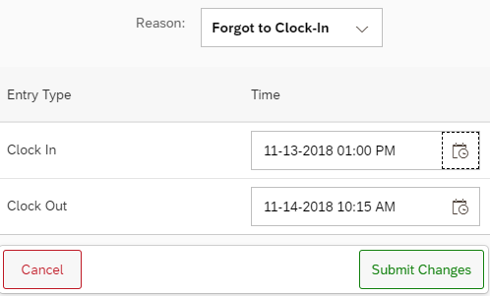
The edit and reason selected will be visible to the supervisor when they approve your time. |  | 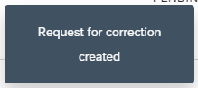

Add Time Pairs
Employees can add time pairs at any time within the current or two previous pay periods.

Please select low-volume usage times if completing any of these tasks on a kiosk or other shared device.

Time Pairs are added due to 1) missed punches and 2) when an employee with multiple positions erroneously records time toward the wrong position.
    - For employees with multiple positions, if time is recorded toward the wrong position, the employee must notify the supervisor of the position for which time was incorrectly recorded to decline the time pair. The employee must use the Add Time feature to add a time pair to the other position.

Newly added pairs will in the supervisor’s queue as PENDING.

If completing this task after you suspect your supervisor has completed their final review prior to the Payroll deadline, please notify them that you have made a change so that they are prompted to review the change.
Click or tap History in the menu bar.

Tap or click Add Time | 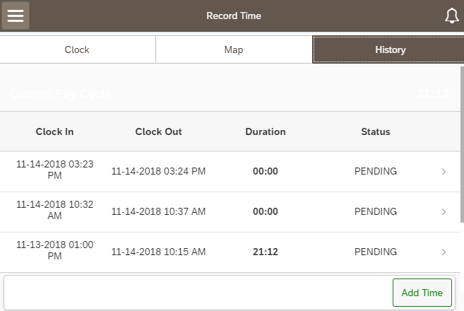
Tap or Click the calendar icon to edit the Clock In date and time. | 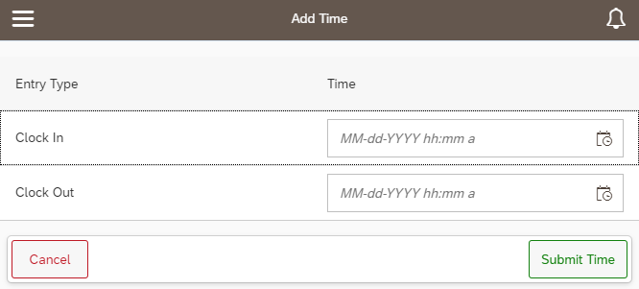
Use the time sliders to indicate the date and the “In” time.  Repeat this process for the Clock Out field.  Click OK | 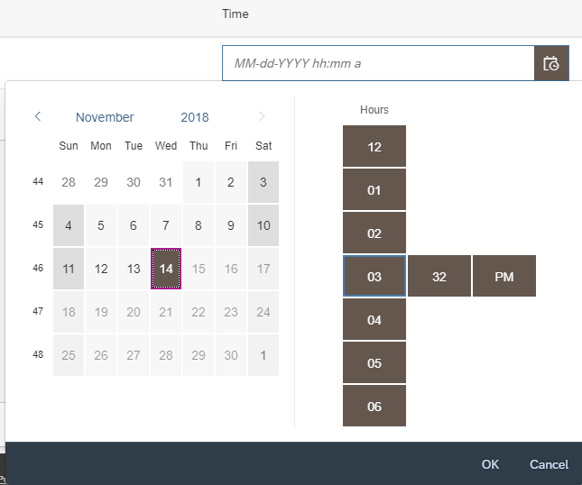
Click Submit Time  The added time pair and reason selected will be visible to the supervisor when they approve your time. | 